
ACTIVITY REPORT
ON
BMSCE ACM Student Chapter Annual General Meeting 2025

- Name of the Club: BMSCE ACM Student Chapter
- Name of the Activity: BMSCE ACM Student Chapter Annual General Meeting 2025.
- Objectives:
The BMSCE ACM Student Chapter organized the Annual General Meeting 2025 to review the chapter’s key activities and achievements over the past year, discuss future plans and industry collaborations, introduce the newly elected student leadership team for 2025-26, and provide a platform for faculty and students to share their feedback and suggestions to enhance the chapter’s growth and impact.
- Date, Time Venue of the Activity:
EVENT | BMSCE ACM Student Chapter Annual General Meeting 2025
DATE/DAY | Thursday, 20th March 2025
TIME | 2:00 pm to 4:00 pm
VENUE | Auditorium - 2, PJA Block
- Name and details of collaborating agency (if it is collaborative/joint activity): None

- Brief summary of the Event:
The event commenced with a welcome speech by Roshini, setting the stage for an engaging session. This was followed by the traditional lighting of the lamp by the dignitaries, symbolizing the beginning of a new tenure for the chapter. Next, the Faculty Core members, Dr. Gowrishankar who is the Faculty Advisor and Dr. Seemanthini K who is the Faculty Sponsor were introduced, acknowledging their continued support and guidance. The Outgoing Office Bearers were then introduced and presented with mementos and certificates, recognizing their efforts and contributions to the chapter over the past year. Dr. Seemanthini K, was also presented with a memento and certificate for her constant support and contribution as the Faculty Sponsor of the chapter.
The Outgoing Office Bearers delivered speeches highlighting the chapter’s progress and achievements. Harshavardhan presented the Secretary report for the year 2024 - 25 highlighting the major events conducted by the chapter during the year. Srujana provided an overview of the chapter’s annual achievements and growth of the chapter in terms of recognition and memberships. Followed by this Bhuvan presented the financial report for the tenure 2024 - 25, specifying the opening and closing balance amount and income and expenditure amount. Following this, Meghana introduced the newly appointed Office Bearers by presenting their certificates for serving as the Junior Coordinators and officially welcomed them into their roles.
The Chairperson for the tenure 2025 - 26 then addressed the gathering, outlining the chapter’s vision and goals for the year 2025 - 26. This was followed by a speech from Dr. Seemanthini K, the Faculty Sponsor, who shared valuable insights and guidance for the chapter’s future endeavors.
The event concluded with a vote of thanks, expressing gratitude to the attendees, to the faculty, outgoing leadership and members for their contributions. The Annual General Meeting served as a significant milestone in shaping the future of the BMSCE ACM Student Chapter, paving the way for continued growth and success
- Outcomes:
The BMSCE ACM Student Chapter Annual General Meeting 2025 was a great chance to look back at the chapter’s progress, welcome the new leaders, and plan for the future. The open forum allowed students and faculty to share their thoughts, making the chapter’s vision for the next year stronger.
- Number of participants:
Number of Faculty | Number of Students
3 | 41

- Photographs of the event:
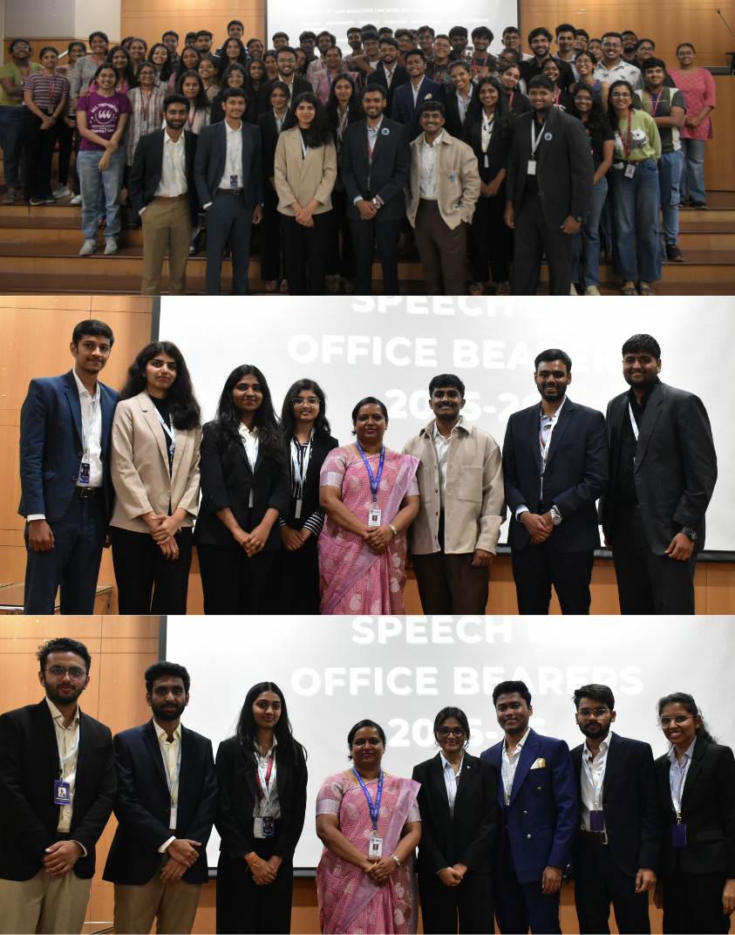
- Supporting Documents:

- Circulars/ Brochures:
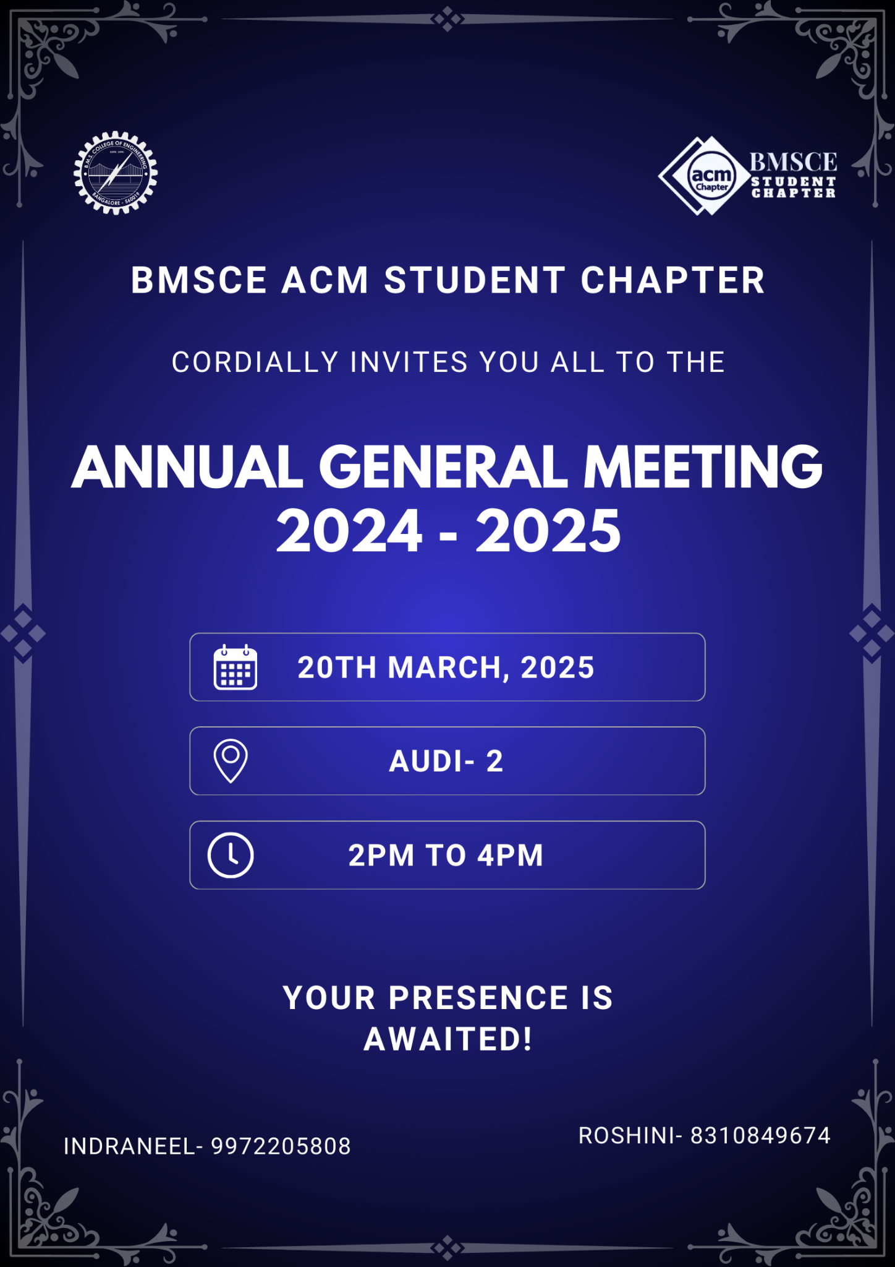

- Attendance:

Name | USN | Email
Saakshi C B | 1BM24AI132 | saakshicb.ai24@bmsce.ac.in
Ananthasai L | 1BM24AD005 | ananthasail.ad24@bmsce.ac.in
P Sai Nieojitha | 1BM24AD036 | sainieojitha.ad24@bmsce.ac.in
Rohan Poddar | 1BM24CS238 | rohanpoddar.cs24@bmsce.ac.in
A Hemcharan | 1BM24AI001 | ahemcharan.ai24@bmsce.ac.in
Smrithi Bhat | 1BM24AI163 | smrithibhat.ai24@bmsce.ac.in
M Tejeswara raju | 1BM24AI110 | tejeswararaju.ai24@bmsce.ac.in
Dasari lalit | 1BM24AI040 | dasarilalit.ai24@bmsce.ac.in
Ritu.R.Heroorkar | 1BM24AI144 | ritur.ai24@bmsce.ac.in
Naysha Navin Shrivastava | 1BM24CS084 | nayshanavin.cs24@bmsce.ac.in
Shreya Bharadwaj | 1BM24AI157 | shreyabharadwaj.ai24@bmsce.ac.in
Harshith Praveen | 1BM24AI073 | harshithpraveen.ai24@bmsce.ac.in
Chiranthana S P | 1BM24AI051 | chiranthanasp.ai.24@bmsce.ac.in
Dhruv Jain | 1BM24AI058 | dhruvjain.ai24@bmsce.ac.in
Sai Adithya D | 1BM24AI136 | saiadithya.ai24@bmsce.ac.in
Sahithya Arjunan | 1BM24AI135 | sahithyaarjunan.ai24@bmsce.ac.in
D.N. Jaishree | 1BM24AI053 | dnjaishree.ai24@bmsce.ac.in
Likith R | 1BM24CS156 | likithr.cs24@bmsce.ac.in
Ashmith.M.A | 1BM24AI036 | ashmithma.ai24@bmsce.ac.in
Rohan Poddar | 1BM24CS238 | rohanpoddar.cs24@bmsce.ac.in
Sainandini M | 1BM24AI138 | sainandinim.ai24@bmsce.ac.in
G.Vignesh | 1BM24AI063 | gandlavignesh.ai24@bmsce.ac.in
Shilpa Kumari | 1BM24AI154 | shilpakumari.ai24@bmsce.ac.in
Navya Agrawal | 1BM24CS195 | navyaagrawal.cs24@bmsce.ac.in
Kritarth Teli | 1BM24CS150 | kritarthteli.cs24@bmsce.ac.in
Moomal changal | 1BM24CS179 | moomalchangal.cs24@bmsce.ac.in
Nandini Aggarwal | 1BM24CS192 | nandiniaggarwal.cs24@bmsce.ac.in
Arsh Thakur | 1BM24CS053 | arshthakur.cs24@bmsce.ac.in
Praneeth Nandan. R | 1BM24AI136 | praneethnandan.ai24@bmsce.ac.in
Saranya Swagatika | 1BM24CS259 | saranyaswagatika.cs24@bmsce.ac.in
Vansh Singh Rawat | 1BM24CS330 | vanshsingh.cs24@bmsce.ac.in
Aditya Aaryan | 1BM24CS019 | adityaaaryan.cs24@bmsce.ac.in
Murra Sai Keerthana | 1BM24CS183 | SaiKeerthana.cs24@bmsce.ac.in
Navaneet.S | 1BM24CS183 | navaneets.cs24@bmsce.ac.in
C Yuktha Shree | 1BM23AI049 | cyuktha.ai23@bmsce.ac.in
Manisha Raj | 1BM23AI047 | manisharaj.ai23@bmsce.ac.in
A JAYALAKSHMI | 1BM23AI001 | ajayalakshmi.ai23@bmsce.ac.in
Bhumika S | 1BM23AI043 | bhumikas.ai23@bmsce.ac.in
Asmitha Reddy. M | 1BM23AI039 | asmithareddy.ai23@bmsce.ac.in
K Sai Sri Harsha | 1BM23EC110 | ksai.ec23@bmsce.ac.in

